If expressions

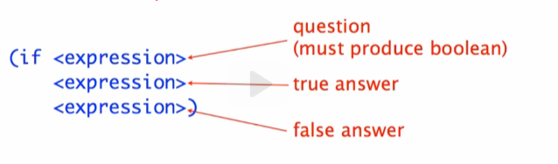

(if [condition]

[true answer expression]

[false answer expression])

Example:

(if [condition]



[true answer expression]

[false answer expression])

 -> 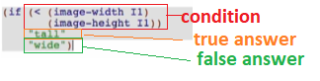

Running:

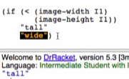

* Highlighted expression in code means that it is the other value that is not chosen by if